Equality, Diversity and Inclusion Policy
  - East to West European Association Ltd
Document owner | Board of Directors and Equality Lead
Version | 1.0
Approval status | Approved by the Board of Directors
Approval date | 3 August 2026
Effective date | 3 August 2026
Next review date | 3 August 2027, or earlier if required
Registered office 36 Broad Mead, Luton LU3 1RX · etweassociation@gmail.com
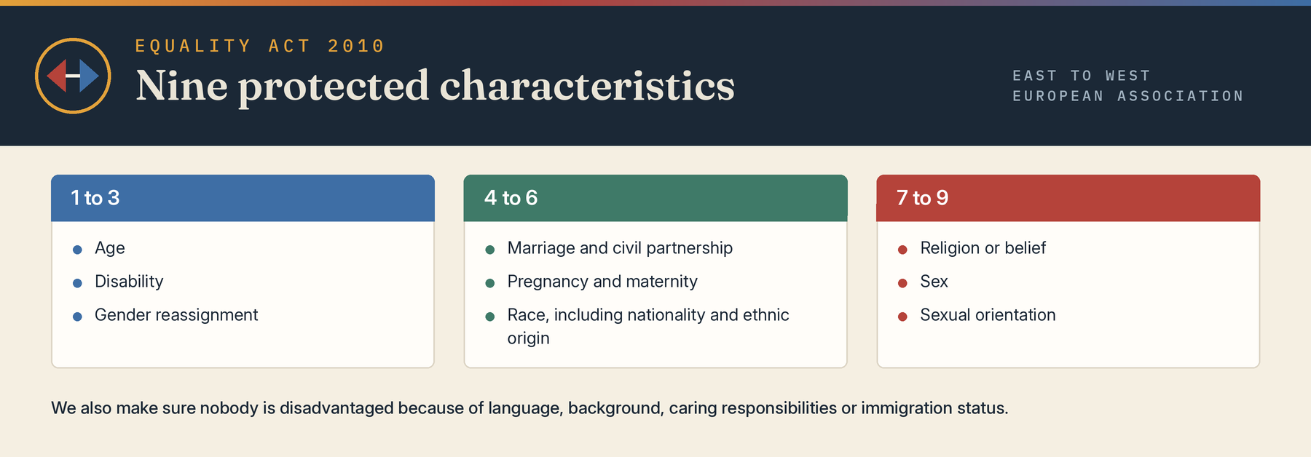

1 Policy statement
East to West European Association Ltd is committed to equality of opportunity, valuing diversity and creating an inclusive community where everyone is treated with dignity and respect. As an organisation founded to support Eastern European communities in the UK and to build understanding between Eastern and Western Europe, we will not tolerate discrimination, harassment or victimisation in any of our projects, services or working relationships.
We recognise that people face different barriers, and that treating people fairly sometimes means treating them differently. We will actively remove barriers so that everyone can take part in, benefit from and contribute to our work.

2 Scope
This policy applies to directors, members, staff, volunteers, sessional workers, contractors, participants, partners and visitors. It covers all our activities, including integration workshops, information sessions, women’s support programmes, youth and family activities, educational programmes and language support, cultural celebrations, networking events, consultations, outreach, recruitment, volunteering, communications, procurement and governance, in person or online.

3 Legal framework
This policy is based on the Equality Act 2010 and Article 29 of the Association’s Articles of Association. The Act protects people from discrimination because of nine protected characteristics: age; disability; gender reassignment; marriage and civil partnership; pregnancy and maternity; race, including colour, nationality and ethnic or national origin; religion or belief; sex; and sexual orientation.
Beyond the law, we also seek to ensure no one is disadvantaged because of language, social or economic background, caring responsibilities, literacy, immigration status or where they live.

4 Unacceptable behaviour
The following are prohibited and will be treated as misconduct, including online and at social events connected with the Association:
- direct discrimination: treating someone less favourably because of a protected characteristic, including by association or perception
- indirect discrimination: a rule or practice that disadvantages a group and cannot be objectively justified
- discrimination arising from disability, and failure to make reasonable adjustments
- harassment, including sexual harassment, as set out in the Anti-Harassment and Sexual Harassment Policy
- victimisation of anyone who makes or supports a complaint, and bullying or abuse of power

5 Our commitments
- use accessible venues wherever possible and ask about access needs at registration
- provide information in plain English, and in Romanian, other languages, large print or easy read on request
- respect cultural and religious needs, including diet, prayer times and festivals, when planning events
- consult our community through consultations and focus groups when shaping projects
- recruit staff and volunteers fairly and on merit, advertise widely and offer reasonable adjustments at every stage
- provide equal access to training, supervision and expenses, and include equality in every induction
- aim for a Board and membership that reflect the communities we serve, and consider equality impact in major decisions
- make sure partners, funders and suppliers share our commitment to equality
- use inclusive language and images, and keep our website and documents as accessible as reasonably possible

6 Responsibilities
The Board of Directors is accountable for this policy. The Equality Lead, Mihaela Veronica Pruteanu (+44 7426 957995), promotes it, advises colleagues, handles concerns and reports to the Board. Project leads put it into practice and challenge inappropriate behaviour. Everyone taking part in our activities is expected to treat others with respect.

7 Raising a concern
Anyone who experiences or witnesses discrimination, harassment or bullying can raise it with a project lead, the Equality Lead or either director, in person, by email to etweassociation@gmail.com, through www.etweassociation.org, or in writing to 36 Broad Mead, Luton LU3 1RX. Concerns from the public are handled under the Complaints Policy. Every concern is taken seriously and handled confidentially, and no one will be victimised for raising a concern in good faith.

8 Monitoring and review
We collect anonymous, voluntary equality monitoring information to check that our services and opportunities reach everyone fairly, processed under the Data Protection Policy. The Board receives an annual equality report and reviews this policy every 12 months, or sooner if the law or our activities change.

Board approval
This policy was approved by the Board of Directors on 3 August 2026, the date of incorporation, and the approval is recorded in the Board minutes.
Approved by | Board of Directors
Director name | Mihaela Veronica Pruteanu (Director and Chair) and Cristina Giorgiana Tutu (Director)
Signature | Signed copy held at the registered office
Date | 3 August 2026

