Whistleblowing Policy
  - East to West European Association Ltd
Document owner | Board of Directors and Whistleblowing Contact
Version | 1.0
Approval status | Approved by the Board of Directors
Approval date | 3 August 2026
Effective date | 3 August 2026
Next review date | 3 August 2027, or earlier if required
Registered office 36 Broad Mead, Luton LU3 1RX · etweassociation@gmail.com
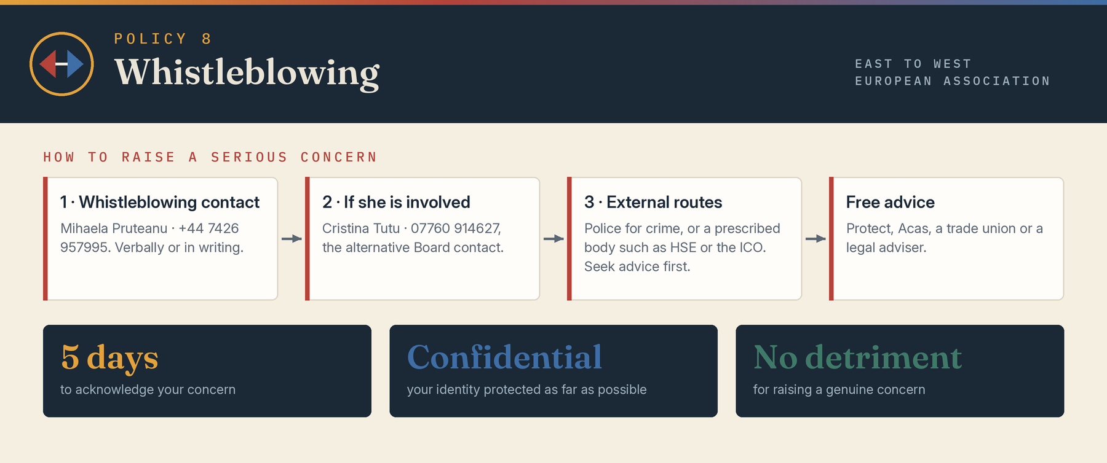

1 Purpose
This policy provides a safe route for workers and volunteers to raise serious concerns about wrongdoing connected with the Association. It supports early reporting, lawful investigation and protection from retaliation. It does not replace personal grievance, safeguarding or complaints procedures, although concerns may overlap.

2 Protected disclosures
Under Part IVA of the Employment Rights Act 1996, a qualifying disclosure is information which the worker reasonably believes tends to show specified wrongdoing and is made in the public interest. Wrongdoing may include a criminal offence, breach of legal obligation, miscarriage of justice, danger to health and safety, environmental damage, or deliberate concealment of any of these. Statutory protection depends on the legal tests and the route used.

3 Wider organisational concerns
Volunteers may not always have statutory whistleblowing status, but the Association will apply the same non-retaliation principle to genuine public-interest concerns. Safeguarding, fraud, bribery, serious data breaches, misuse of funds, regulatory breaches and serious concealment should be reported promptly.

4 How to report
Concerns should normally be raised with the nominated Whistleblowing Contact or a director. If the concern involves that person, it may be raised with another director or the Board Chair. Reports may be verbal or written and should include the facts, dates, people, evidence, risk and whether the concern was raised before.
- Whistleblowing Contact: Mihaela Veronica Pruteanu · +44 7426 957995 · etweassociation@gmail.com
- Alternative Board contact: Cristina Giorgiana Tutu · 07760 914627 · etweassociation@gmail.com

5 Emergency and external reporting
Immediate danger or suspected crime may be reported to emergency services or police. Safeguarding concerns must follow the Safeguarding Policy. A worker considering external disclosure should seek independent advice because statutory protection depends on conditions. Prescribed persons may include the Health and Safety Executive, the Information Commissioner, HM Revenue and Customs or another regulator according to subject.

6 Response
The recipient will acknowledge the concern normally within five working days, assess immediate risk and conflicts, decide the appropriate investigator and explain the next steps where possible. The investigation will be proportionate, independent and documented. The reporter may be asked for further information but is not responsible for proving the case.

7 Confidentiality and anonymity
Identity will be protected as far as reasonably possible, but disclosure may be necessary for fair investigation, safeguarding or legal reasons. Anonymous reports will be considered according to seriousness, credibility and available evidence, although anonymity may limit investigation and feedback.

8 Protection and support
No worker will be dismissed or subjected to detriment for making a protected disclosure. The Association will not tolerate retaliation against any person raising a genuine concern. Support, temporary working arrangements and reasonable adjustments will be considered. A person who believes they suffered retaliation should report it immediately.

9 Outcomes and feedback
Appropriate action may include control improvements, recovery of funds, disciplinary or contractual action, safeguarding referral, regulatory notification or police report. The reporter will receive as much feedback as law, confidentiality and fairness permit. No particular outcome can be guaranteed.

10 False allegations and confidentiality breaches
A concern that is mistaken or not upheld will not attract sanction if raised genuinely. Deliberately false or malicious allegations, retaliation, destruction of evidence or inappropriate disclosure of confidential information may be addressed under the relevant conduct procedure.

11 Records and Board oversight
Whistleblowing records will be secure and need-to-know. The Board will receive anonymised assurance on concerns, timeliness, actions and themes, while managing conflicts. Serious incidents will be reported to regulators, funders or insurers where required.

12 Independent advice
Workers may obtain confidential advice from Acas, a trade union, legal adviser or Protect. Reporting internally is encouraged where safe, but this policy does not prevent a disclosure through a legally protected route.

Board approval
This policy was approved by the Board of Directors on 3 August 2026, the date of incorporation, and the approval is recorded in the Board minutes.
Approved by | Board of Directors
Director name | Mihaela Veronica Pruteanu (Director and Chair) and Cristina Giorgiana Tutu (Director)
Signature | Signed copy held at the registered office
Date | 3 August 2026

