Anti Harassment and Sexual Harassment Policy
  - East to West European Association Ltd
Document owner | Board of Directors
Version | 1.0
Approval status | Approved by the Board of Directors
Approval date | 3 August 2026
Effective date | 3 August 2026
Next review date | 3 August 2027, or earlier if required
Registered office 36 Broad Mead, Luton LU3 1RX · etweassociation@gmail.com
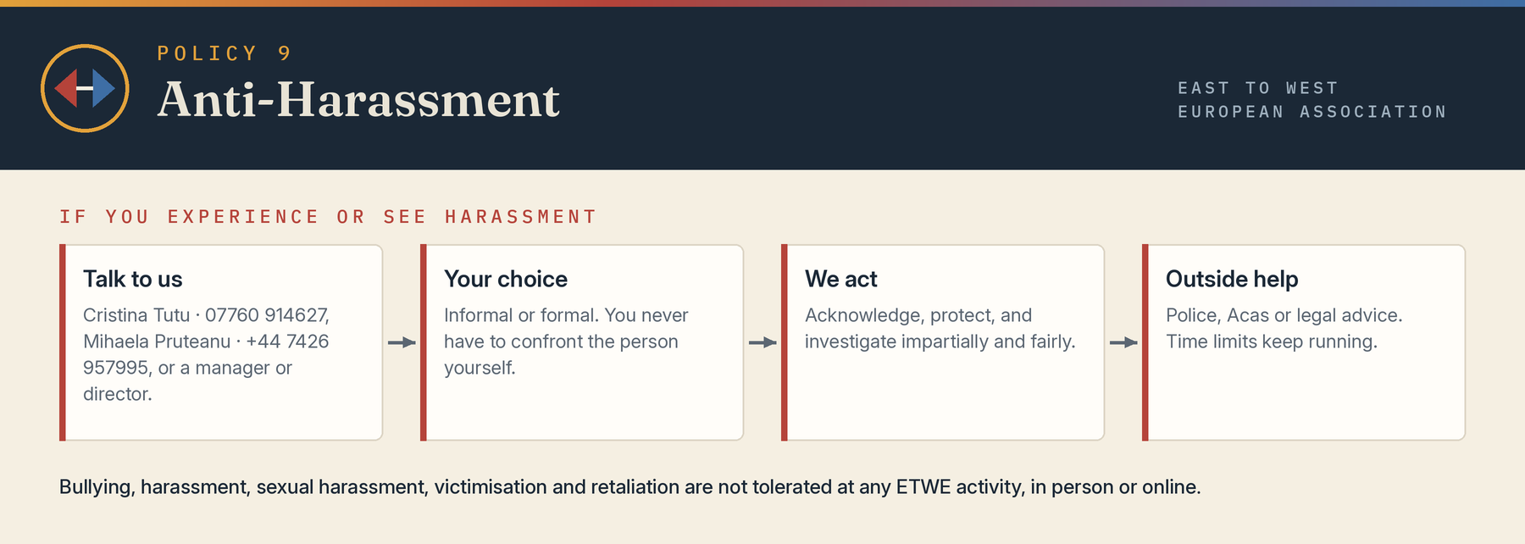

1 Commitment
The Association is committed to an environment free from bullying, harassment, sexual harassment, discrimination, victimisation and retaliation. The policy applies at work, volunteering, services, events, travel, social functions, online communications and other situations connected with the Association.

2 Definitions
Harassment under the Equality Act is unwanted conduct related to a protected characteristic that has the purpose or effect of violating dignity or creating an intimidating, hostile, degrading, humiliating or offensive environment where the statutory provision applies. Sexual harassment is unwanted conduct of a sexual nature having that purpose or effect. Less favourable treatment because a person rejected or submitted to sexual conduct is also prohibited. Bullying may breach this policy even where it is not unlawful harassment.

3 Examples
Conduct may include sexual comments or jokes, intrusive questions, unwanted touching, staring, sexual images, propositions, repeated invitations after refusal, online messages, threats, exclusion, humiliation, discriminatory jokes, mocking disability or accent, outing, retaliation, abuse of authority or conduct by a third party. A single incident may be serious. Intention is relevant but not decisive.

4 Preventive duty
Where the Association employs workers, it will take reasonable steps to prevent sexual harassment, including harassment by third parties. It will assess foreseeable risks, consider power imbalances and lone or public-facing work, set standards, provide suitable training and reporting routes, act on warning signs and review controls after concerns. Managers must not wait for a formal complaint where risk is apparent.

5 Expected behaviour
Everyone must respect consent and personal boundaries, stop conduct when asked, challenge inappropriate behaviour safely, avoid abuse of seniority and cooperate with preventive measures. Managers and activity leads must model standards, respond promptly and escalate concerns.

6 Reporting options
A person may speak to a manager, director, safeguarding lead or nominated harassment contact. The nominated harassment contact is Cristina Giorgiana Tutu (07760 914627); the alternative contact is Mihaela Veronica Pruteanu (+44 7426 957995). Informal action may include stating that conduct is unwelcome, supported conversation or management intervention, but nobody will be required to confront an alleged harasser. Serious, repeated, safeguarding or criminal matters should normally be handled formally.

7 Formal process
The Association will acknowledge the concern, assess immediate protection, appoint an impartial investigator, identify allegations, give relevant parties a fair opportunity to respond, preserve evidence and reach findings on the balance of probabilities. Confidentiality will be maintained on a need-to-know basis, but absolute secrecy cannot be promised. The complainant will be told whether the complaint was upheld and any appropriate remedial steps, subject to privacy.

8 Interim and protective measures
Measures may include changed reporting lines, rota or location, no-contact arrangements, additional supervision, remote work, suspension or exclusion. They are precautionary, must be proportionate and should not unnecessarily disadvantage the complainant.

9 Outcomes and retaliation
Consequences may include training, apology, warning, role restriction, disciplinary or contractual action, removal from activities or referral to police, safeguarding authorities or regulators. Retaliation against a person who reports, supports a complaint or participates in an investigation is prohibited. Knowingly false and malicious allegations may be addressed, but an unsubstantiated complaint is not by itself malicious.

10 Support and external rights
Reasonable adjustments, language support, a companion where appropriate and signposting to specialist help will be considered. Internal procedures do not prevent police reports, safeguarding referrals, Acas contact or legal claims, and statutory time limits continue to run.

11 Monitoring
The Board will review anonymised themes, risk assessments, training, third-party risks and actions at least annually. The policy will be reviewed after serious incidents or legal change.

Board approval
This policy was approved by the Board of Directors on 3 August 2026, the date of incorporation, and the approval is recorded in the Board minutes.
Approved by | Board of Directors
Director name | Mihaela Veronica Pruteanu (Director and Chair) and Cristina Giorgiana Tutu (Director)
Signature | Signed copy held at the registered office
Date | 3 August 2026

