Recruitment and Selection Procedure
  - East to West European Association Ltd
Document owner | Board of Directors and Recruiting Manager
Version | 1.0
Approval status | Approved by the Board of Directors
Approval date | 3 August 2026
Effective date | 3 August 2026
Next review date | 3 August 2027, or earlier if required
Registered office 36 Broad Mead, Luton LU3 1RX · etweassociation@gmail.com
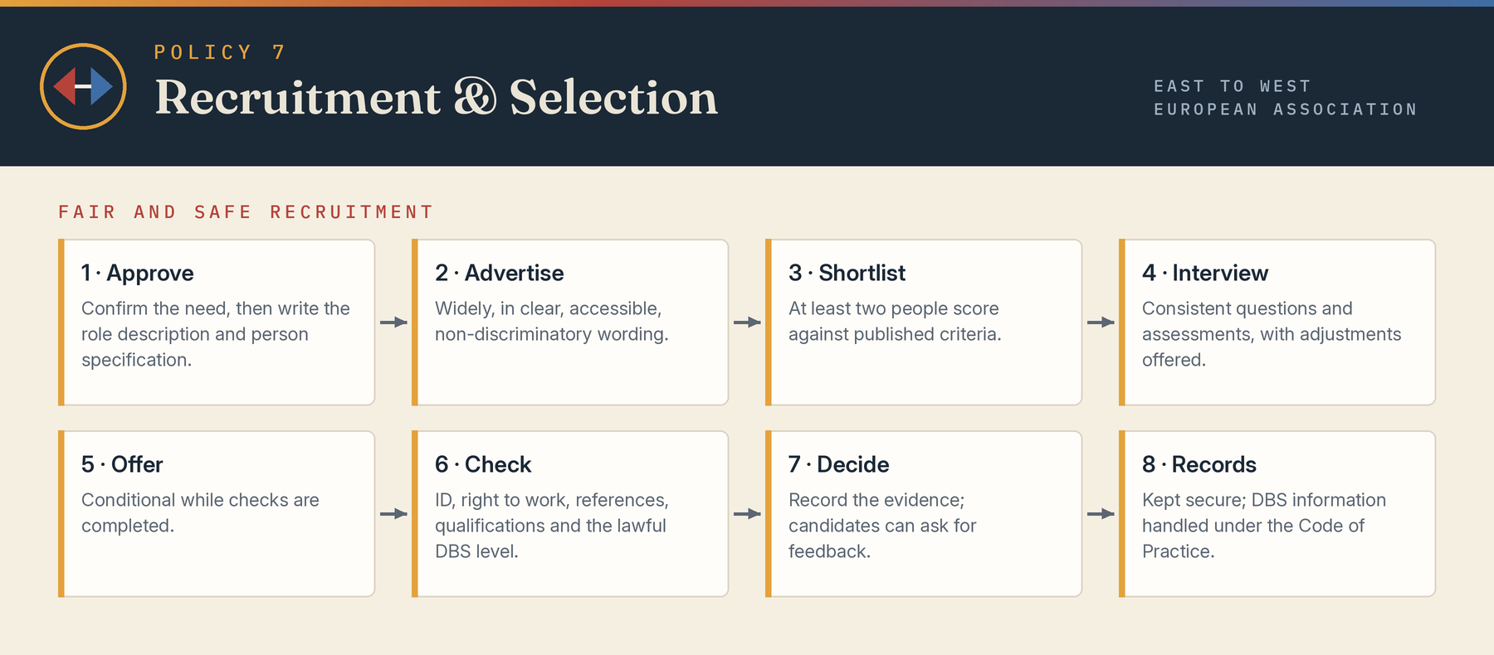

1 Purpose
The Association will recruit employees, workers and volunteers fairly, transparently and safely, using criteria relevant to the role. The procedure supports equal opportunity, safeguarding, data protection and sound governance.

2 Approval and role design
Before advertising, the recruiting manager must confirm the genuine need, status, budget, reporting line and approval. A role description and person specification will distinguish essential from desirable criteria and identify safeguarding responsibilities, checks, working pattern and any lawful occupational requirement.

3 Advertising and outreach
Vacancies should normally be advertised sufficiently widely to support a fair field. Wording must be clear, accessible and non-discriminatory. Positive action may be used only within the Equality Act and must not become automatic preference. Application information will explain adjustments, checks, privacy information and closing arrangements.

4 Shortlisting
At least two people should shortlist where practicable, using a pre-agreed scoring matrix against published criteria. Evidence, not assumption, must determine scores. Equality-monitoring information will be separated from selection. Conflicts of interest and close relationships with candidates must be declared.

5 Interview and assessment
Candidates will receive reasonable notice and be invited to request adjustments. Questions and assessments will test role criteria consistently. Questions about health, disability, family plans, protected characteristics or criminal history will be asked only where legally permitted and relevant. Notes and scores must give a defensible record.

6 Conditional offer and checks
Offers should be conditional where checks remain. Depending on role, checks may include identity, right to work, qualifications, references, conflicts, driving entitlement, professional registration and the legally permitted DBS level. References should normally be obtained at final stage with consent. Health enquiries after offer must be lawful and focused on ability and adjustments.

7 Safeguarding recruitment
Roles involving children or adults at risk require a safeguarding risk assessment, clear boundaries and appropriate references. DBS eligibility will be checked for the actual duties; higher-level checks will not be requested merely as a precaution. From 1 September 2026, the removal of the supervision exemption may place regularly supervised volunteers working with children in regulated activity. Barred-list and referral duties will be followed where applicable.

8 Decisions and feedback
The panel will record the evidence supporting the decision. Any departure from scores must be justified and approved. Candidates will be informed promptly and may request concise feedback. No appointment may start before essential safety or legal checks unless a documented, lawful and risk-controlled exception is approved.

9 Records and retention
Recruitment records will be secure, access-limited and retained for a defined period under the retention schedule. Information will be used only for recruitment and related legal purposes unless the candidate agrees otherwise. DBS certificate information will be handled under the DBS Code of Practice and not copied or retained unlawfully.

10 Complaints
A candidate may raise a recruitment concern under the Complaints Policy or, for workers, the relevant grievance route. Complaints will be reviewed by someone not materially involved where practicable. Statutory rights and time limits remain unaffected.

Board approval
This policy was approved by the Board of Directors on 3 August 2026, the date of incorporation, and the approval is recorded in the Board minutes.
Approved by | Board of Directors
Director name | Mihaela Veronica Pruteanu (Director and Chair) and Cristina Giorgiana Tutu (Director)
Signature | Signed copy held at the registered office
Date | 3 August 2026

