Health and Safety Policy and Arrangements
  - East to West European Association Ltd
Document owner | Board of Directors and Health and Safety Lead
Version | 1.0
Approval status | Approved by the Board of Directors
Approval date | 3 August 2026
Effective date | 3 August 2026
Next review date | 3 August 2027, or earlier if required
Registered office 36 Broad Mead, Luton LU3 1RX · etweassociation@gmail.com
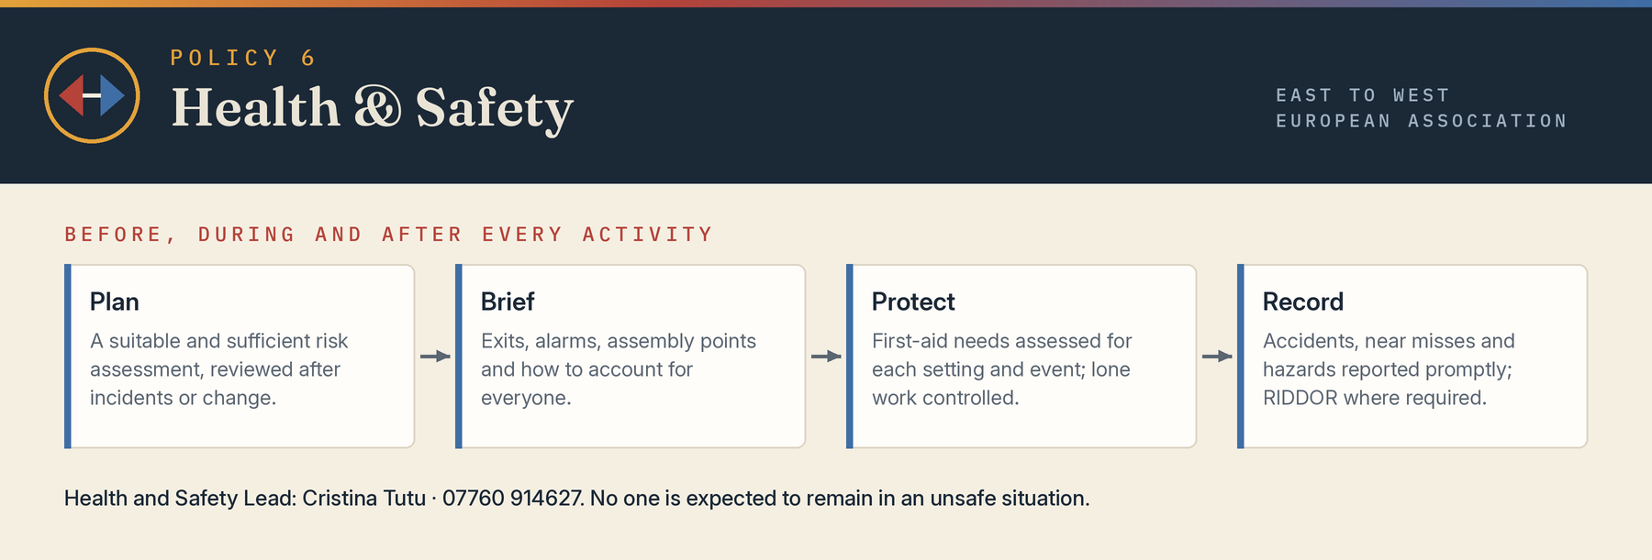

1 Statement of intent
The Association will, so far as reasonably practicable, protect the health, safety and welfare of employees, volunteers, participants, visitors and others affected by its activities. It will provide safe systems, suitable information and training, proportionate supervision, safe equipment and venues, and consultation on relevant risks.

2 Responsibilities
The Board has overall accountability and has appointed a competent Health and Safety Lead, named below. Project leads implement risk controls and brief participants. Employees and volunteers must take reasonable care, follow instructions, report hazards and not interfere with safety equipment. Contractors and venue providers must cooperate and provide relevant risk information.
- Health and Safety Lead: Cristina Giorgiana Tutu · 07760 914627 · etweassociation@gmail.com
- First-aid arrangements: identified in each venue or event risk assessment
- Emergency coordinator: appointed for each significant event

3 Risk assessment and planning
Suitable and sufficient risk assessments will be completed for offices, outreach, events, home or lone working, travel, manual handling, equipment, vulnerable participants, fire, food, infection, violence, weather and any unusual activity. Controls will follow the hierarchy of elimination, substitution, engineering, administrative measures and personal protective equipment. Assessments will be reviewed after incidents or material change.

4 Venues fire and emergencies
Before use, the Association will check venue responsibility, capacity, exits, alarms, accessibility, assembly points, first aid, toilets, security and emergency communication. Activity leads will know how to raise the alarm, evacuate, contact emergency services and account for people. Personal emergency evacuation needs will be considered.

5 Accidents incidents and first aid
Accidents, near misses, violence, ill health and hazards must be reported promptly and recorded. Immediate care and emergency assistance take priority. The Health and Safety Lead will investigate proportionately, preserve relevant evidence and implement learning. Reportable events will be notified under RIDDOR by the legally responsible person. First-aid needs will be assessed for each work setting and event.

6 Lone working and community visits
Lone work will be avoided where risk is unacceptable. Controls may include check-in and check-out, visit details, charged phones, paired working, safe meeting locations, withdrawal authority and emergency escalation. Home visits involving safeguarding, aggression or unfamiliar locations require specific approval and risk assessment.

7 Equipment manual handling and display screens
Equipment must be suitable, maintained and used only by competent people. Manual handling should be avoided or reduced and assessed where unavoidable. Regular display-screen users will receive suitable workstation arrangements and breaks. Electrical equipment defects must be isolated and reported.

8 Wellbeing violence and stress
The Association will assess foreseeable violence, harassment, traumatic material and work-related stress. Workloads, supervision, debriefing, boundaries and support will be considered. No person is expected to remain in an unsafe situation.

9 Children and adults at risk
Safety planning for children and adults at risk must align with the Safeguarding Policy and include supervision, consent, medical needs, allergies, collection arrangements, transport, missing-person response and accessibility.

10 Monitoring review and consultation
The Board will receive information on incidents, outstanding actions, training and significant risks. Workers and volunteers will be encouraged to report concerns and suggest improvements. This policy and local arrangements will be reviewed annually and after serious incidents or material legal or operational change.

11 Legal references
Health and Safety at Work etc Act 1974; Management of Health and Safety at Work Regulations 1999; Workplace Health Safety and Welfare Regulations 1992; Regulatory Reform Fire Safety Order 2005; RIDDOR 2013; First-Aid Regulations 1981, as applicable.

Board approval
This policy was approved by the Board of Directors on 3 August 2026, the date of incorporation, and the approval is recorded in the Board minutes.
Approved by | Board of Directors
Director name | Mihaela Veronica Pruteanu (Director and Chair) and Cristina Giorgiana Tutu (Director)
Signature | Signed copy held at the registered office
Date | 3 August 2026

