Code of Conduct
  - East to West European Association Ltd
Document owner | Board of Directors
Version | 1.0
Approval status | Approved by the Board of Directors
Approval date | 3 August 2026
Effective date | 3 August 2026
Next review date | 3 August 2027, or earlier if required
Registered office 36 Broad Mead, Luton LU3 1RX · etweassociation@gmail.com
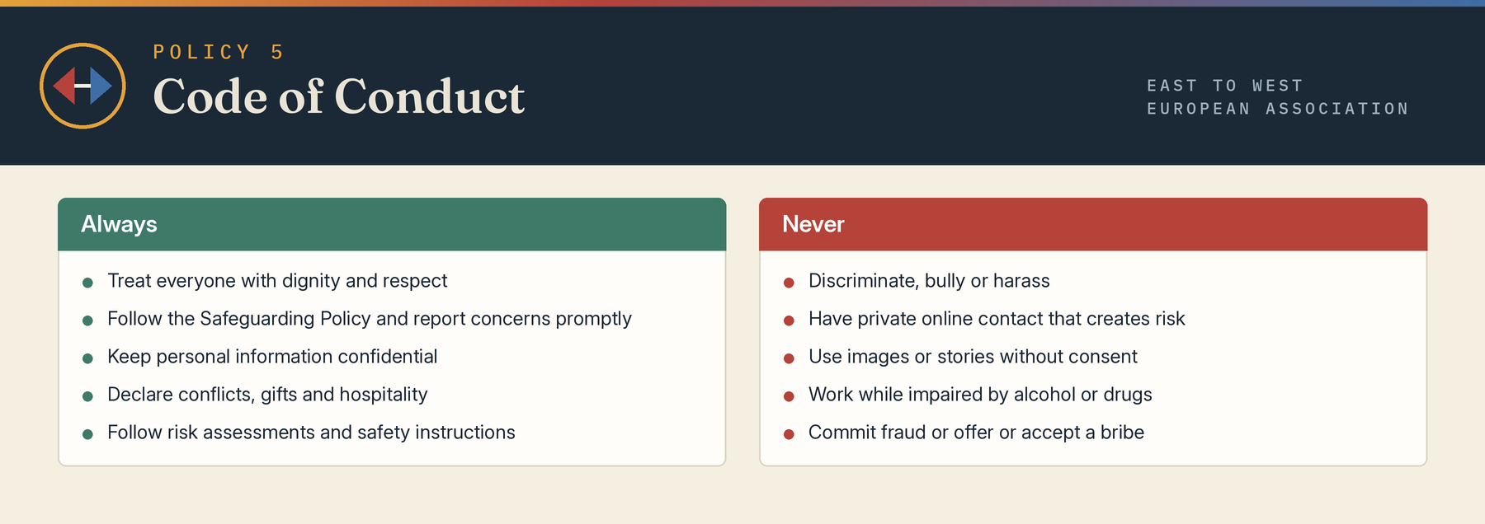

1 Purpose and application
This Code sets the standards expected of directors, employees, workers, volunteers, contractors, facilitators and representatives when acting for or with the Association, including online, at events and during travel or outreach.

2 Respect and inclusion
Everyone must treat others with dignity, respect boundaries, use inclusive language, avoid stereotypes and comply with the Equality Diversity and Inclusion Policy. Discrimination, bullying, harassment, sexual harassment, victimisation, hate-related behaviour and retaliation are prohibited.

3 Safeguarding and professional boundaries
People must follow the Safeguarding Policy, report concerns promptly, avoid inappropriate one-to-one or private online contact, never exploit trust, and not exchange money, gifts, personal services or intimate communications in a way that creates risk or dependency. Sexual or romantic conduct with a current child beneficiary is prohibited. Conduct involving adults at risk must respect capacity, consent and professional boundaries.

4 Integrity and authority
Representatives must be honest, act within delegated authority, give accurate information, keep commitments or explain changes, and not misuse the Association’s name, logo, funds, property or relationships. Fraud, bribery, facilitation payments, theft and falsification of records are prohibited.

5 Confidentiality and data
Confidential and personal information must be accessed only for authorised purposes, shared only where lawful and necessary, stored securely and returned or deleted as directed. Safeguarding and whistleblowing concerns must be reported through proper channels and are not silenced by confidentiality.

6 Conflicts gifts and hospitality
Actual, potential and perceived conflicts must be declared promptly and recorded. A person must withdraw from a decision where impartiality may reasonably be questioned. Gifts or hospitality must never influence a decision; anything more than modest and occasional must be declared and may need to be refused.

7 Communications and social media
Communications must be respectful, accurate and authorised. No person may speak publicly for the Association without authority. Personal views must not be presented as the Association’s position. Images and stories require appropriate consent and must protect dignity, privacy and safeguarding.

8 Safety substances and criminal conduct
Everyone must follow risk assessments, emergency procedures and reasonable safety instructions. A person must not undertake duties while impaired by alcohol, illegal drugs or misused medication. Violence, threats, possession of weapons and criminal conduct connected with Association activity are prohibited.

9 Reporting and consequences
Concerns should be reported to the activity lead, director, safeguarding lead or whistleblowing contact according to subject. Genuine reports will be protected from retaliation. Breach may lead to advice, training, restriction, removal, disciplinary or contractual action, referral to authorities or termination of involvement.

Board approval
This policy was approved by the Board of Directors on 3 August 2026, the date of incorporation, and the approval is recorded in the Board minutes.
Approved by | Board of Directors
Director name | Mihaela Veronica Pruteanu (Director and Chair) and Cristina Giorgiana Tutu (Director)
Signature | Signed copy held at the registered office
Date | 3 August 2026

