Volunteer Policy
  - East to West European Association Ltd
Document owner | Board of Directors and Volunteer Coordinator
Version | 1.0
Approval status | Approved by the Board of Directors
Approval date | 3 August 2026
Effective date | 3 August 2026
Next review date | 3 August 2027, or earlier if required
Registered office 36 Broad Mead, Luton LU3 1RX · etweassociation@gmail.com
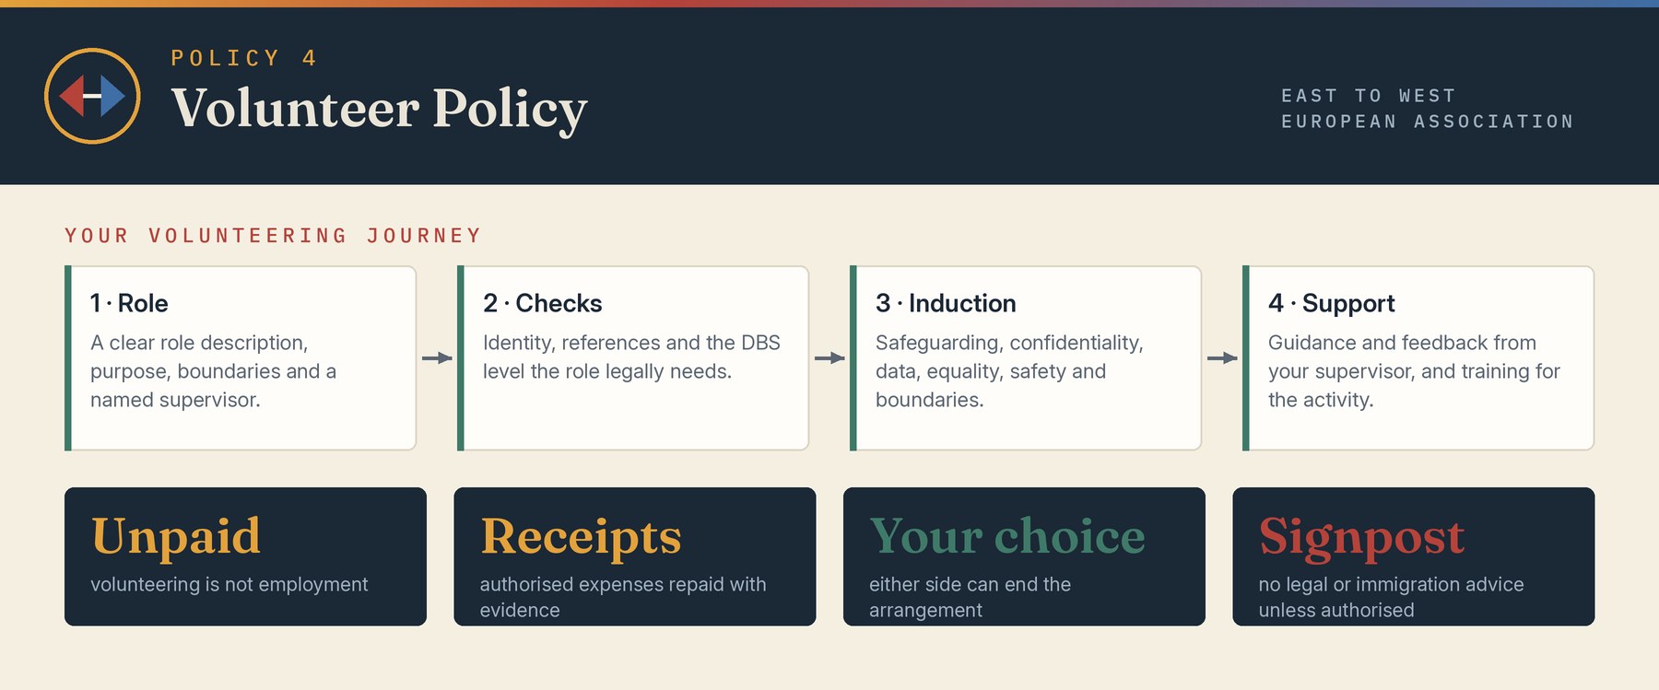

1 Purpose
Volunteers contribute time and skills to support the Association’s community purposes. This policy explains recruitment, support, expenses, conduct, safeguarding and how volunteer arrangements may end. It aims to provide a fair and positive experience without creating an employment relationship.

2 Status
Volunteering is unpaid and is not a contract of employment or worker relationship. No minimum work is guaranteed and volunteers are not obliged to accept tasks. The Association may reimburse authorised out-of-pocket expenses against evidence; reimbursement is not wages. Any separate legally binding agreement must be expressly identified.

3 Recruitment and checks
Roles will have a clear description, purpose, boundaries, supervisor and required checks. Selection will be proportionate and inclusive. Identity, references, right-to-volunteer restrictions where relevant, safeguarding suitability and the legally permitted DBS level will be checked according to the role. A criminal record will not automatically exclude a person unless law or risk requires it.

4 Induction and support
Volunteers will receive induction covering the role, safeguarding, confidentiality, data protection, equality, health and safety, boundaries, expenses and reporting. A named supervisor will provide reasonable guidance and feedback. Training must match the activity and volunteers must not undertake tasks beyond competence or authorisation.

5 Equality and adjustments
The Association will seek to make volunteering accessible and will consider reasonable adjustments. Role requirements and selection criteria will be relevant and proportionate. Volunteers must follow the Equality Diversity and Inclusion Policy and Code of Conduct.

6 Conduct and boundaries
Volunteers must act within their role, maintain confidentiality, use resources responsibly, avoid conflicts, keep accurate records, follow safeguarding and safety procedures, and not present themselves as authorised to give legal, immigration, financial, medical or other regulated advice unless expressly qualified and authorised.

7 Expenses and property
Authorised travel, subsistence or activity costs may be reimbursed under the expenses procedure. Prior approval and receipts are normally required. Association property, information, accounts and access credentials must be protected and returned promptly when requested.

8 Concerns and problem solving
A volunteer should raise role or treatment concerns with the supervisor or a director. The Association will seek an informal resolution where appropriate and use a fair review for serious matters. Volunteers may use safeguarding, whistleblowing, anti-harassment or complaints routes according to the issue.

9 Ending the arrangement
Either party may end the volunteering arrangement at any time. Where practicable, notice and an explanation will be given. Immediate restriction or termination may occur for safety, safeguarding, serious misconduct, confidentiality breach, loss of funding, role change or organisational need. There is no employee disciplinary or redundancy entitlement.

10 Records and references
Volunteer records will be processed under the Data Protection Policy. Any reference will be accurate, fair and limited to information the Association can verify.

Board approval
This policy was approved by the Board of Directors on 3 August 2026, the date of incorporation, and the approval is recorded in the Board minutes.
Approved by | Board of Directors
Director name | Mihaela Veronica Pruteanu (Director and Chair) and Cristina Giorgiana Tutu (Director)
Signature | Signed copy held at the registered office
Date | 3 August 2026

