Data Protection Policy and Privacy Notice
  - East to West European Association Ltd
Document owner | Board of Directors and Data Protection Lead
Version | 1.0
Approval status | Approved by the Board of Directors
Approval date | 3 August 2026
Effective date | 3 August 2026
Next review date | 3 August 2027, or earlier if required
Registered office 36 Broad Mead, Luton LU3 1RX · etweassociation@gmail.com
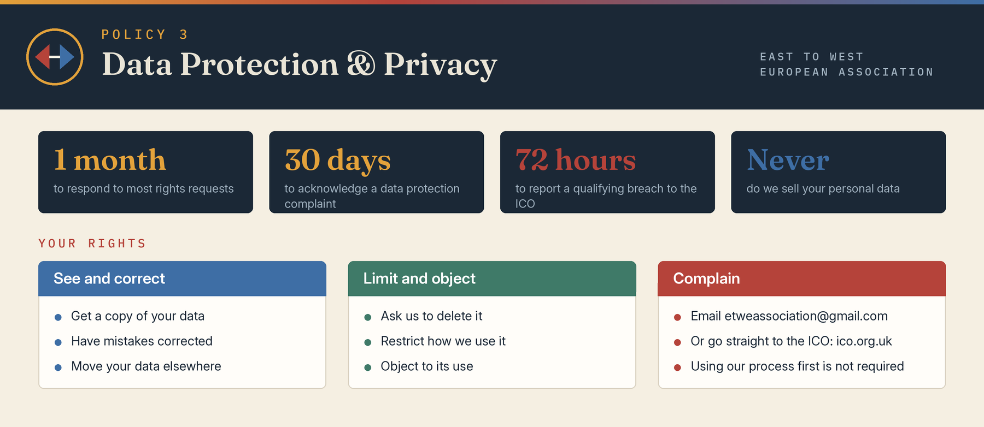

1 Purpose and controller details
East to West European Association Ltd, company number 17378486, is the controller for personal information used for its own purposes. Its registered office is 36 Broad Mead, Luton, England, LU3 1RX. Enquiries and data-protection complaints may be sent to etweassociation@gmail.com, through www.etweassociation.org or by post. The Data Protection Lead is Mihaela Veronica Pruteanu (+44 7426 957995).
This document contains the internal governance policy followed by the public-facing privacy information required when the Association collects personal data. Activity-specific notices may supplement it where necessary.

2 Legal framework
The Association will comply with the UK GDPR, Data Protection Act 2018, Privacy and Electronic Communications Regulations where applicable, and amendments made by the Data Use and Access Act 2025. Processing will be lawful, fair and transparent; purpose-limited; adequate, relevant and limited; accurate; retained no longer than necessary; secure; and demonstrably accountable.

3 Information we may collect
Depending on the service or relationship, information may include identity and contact details, age and demographic information, service and referral records, attendance, communications, feedback, volunteer or recruitment records, safeguarding and risk information, payment or expense information, photographs or recordings, technical website information and equality-monitoring data. We will not collect information merely because it may be useful later.

4 Special category and criminal-offence data
Health, ethnicity, religion, sexual orientation and other special-category information will be used only where an Article 6 lawful basis and Article 9 condition apply. Criminal-offence data will be processed only with lawful authority. Where required, a Schedule 1 Data Protection Act condition and Appropriate Policy Document will be maintained. Safeguarding information will receive enhanced access and retention controls.

5 Purposes and lawful bases
Personal information may be used to provide and evaluate services, manage participation and accessibility, communicate, safeguard people, recruit and support staff or volunteers, administer governance and membership, manage partners and suppliers, meet legal or funding requirements, prevent fraud, defend claims and improve services. The lawful basis may be contract, legal obligation, vital interests, legitimate interests, consent or public task where applicable. Consent will not be used where there is no genuine choice.

6 Children and online services
Children’s information will be handled with particular care and notices will use age-appropriate language. Where the Association provides an online service likely to be used by children, it will consider children’s higher protection matters at design stage, minimise profiling and complete a data protection impact assessment where risk warrants it.

7 Sharing and processors
Information may be shared where necessary with local authorities, safeguarding partners, police, health or support services, funders, insurers, professional advisers, technology providers, venues and delivery partners. Processors must be selected with due diligence and bound by compliant written terms. Information will not be sold. Safeguarding and legal disclosures may be made without consent where authorised by law.

8 International transfers
Personal data will not be transferred outside the United Kingdom unless the transfer is lawful and appropriate safeguards or a recognised adequacy arrangement applies. The Association will document the transfer mechanism and assess relevant risks.

9 Security and breaches
The Association will use access controls, strong authentication, secure devices and storage, backups, confidentiality expectations, staff training and safe disposal. Suspected loss, unauthorised disclosure, alteration or access must be reported immediately to the Data Protection Lead. Breaches will be contained, assessed, recorded and, where required, reported to the ICO within 72 hours and communicated to affected people.

10 Retention
Retention periods will be set by record type, taking account of purpose, safeguarding, limitation periods, funding, tax, insurance and legal duties. Records will then be securely deleted, anonymised or archived under lawful controls. A retention schedule will be approved separately and reviewed annually.

11 Individual rights
Subject to legal conditions and exemptions, individuals may request access, correction, erasure, restriction, objection, portability and safeguards concerning solely automated decisions. Identity may be verified proportionately. Requests will be handled within the statutory period and extensions used only where lawful.

12 Data protection complaints
The Association will provide an accessible electronic route for data-protection complaints, acknowledge a complaint within 30 days and respond without undue delay. The response will explain the outcome and any action. A person may also complain to the Information Commissioner’s Office at ico.org.uk; using the internal process is not a prerequisite.

13 Direct marketing and cookies
Electronic marketing will comply with UK GDPR and PECR. People will be told how to opt out and objections will be respected. Any charity soft opt-in will be used only if the Association is legally eligible and all statutory conditions are met. Non-essential cookies will not be used without valid consent unless a lawful exemption applies.

14 Accountability
The Association will maintain appropriate processing records, privacy information, contracts, training, breach records, rights-request logs, consent evidence where relevant and data-protection impact assessments for high-risk processing. Data protection by design and default must be applied to new systems, forms, projects and partnerships.

15 Privacy notice summary
When information is collected, the person must be told who controls it, the purposes and lawful bases, categories collected, recipients, transfers, retention, rights, complaint routes, whether provision is required and any relevant automated decision-making. This document must be supplemented at the point of collection if those details are not already clear.

Board approval
This policy was approved by the Board of Directors on 3 August 2026, the date of incorporation, and the approval is recorded in the Board minutes.
Approved by | Board of Directors
Director name | Mihaela Veronica Pruteanu (Director and Chair) and Cristina Giorgiana Tutu (Director)
Signature | Signed copy held at the registered office
Date | 3 August 2026

