Complaints Policy and Procedure
  - East to West European Association Ltd
Document owner | Board of Directors
Version | 1.0
Approval status | Approved by the Board of Directors
Approval date | 3 August 2026
Effective date | 3 August 2026
Next review date | 3 August 2027, or earlier if required
Registered office 36 Broad Mead, Luton LU3 1RX · etweassociation@gmail.com
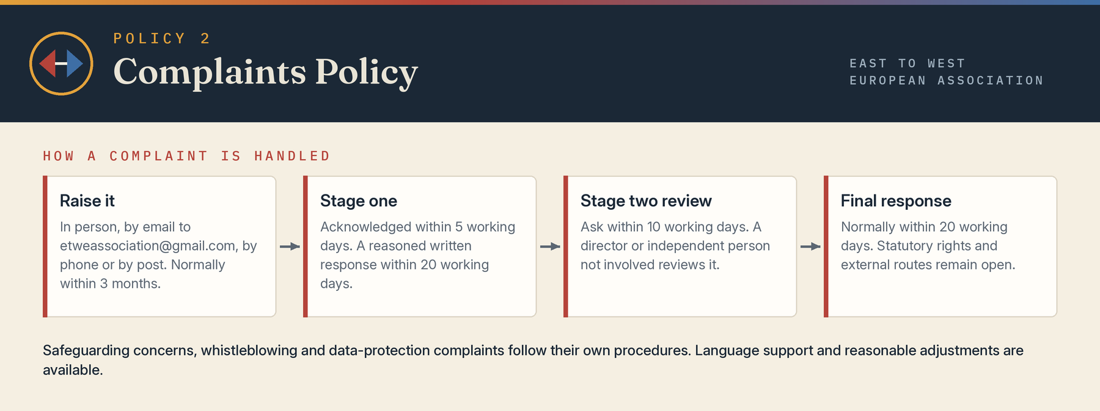

1 Purpose
The Association welcomes complaints as an opportunity to put matters right, learn and improve. This procedure provides an accessible, fair and proportionate route for concerns about services, projects, conduct, decisions or communications. A complaint may be made verbally or in writing and reasonable adjustments or language support will be considered.

2 Scope
This procedure is for service users, participants, members of the public, partners, suppliers and other stakeholders. Employment grievances, whistleblowing, safeguarding allegations, data-protection complaints and appeals governed by a separate statutory or contractual process will be routed to the appropriate procedure. A safeguarding or immediate-safety issue takes priority.

3 Principles
Complaints will be handled impartially, confidentially as far as possible, without retaliation and by someone not directly involved where practicable. The Association will distinguish dissatisfaction from a request for service, appeal, safeguarding report or protected disclosure. Anonymous complaints will be considered according to seriousness and available evidence.

4 How to complain
A complaint should explain what happened, when, who was involved, the effect and the outcome sought. It may be sent by email to etweassociation@gmail.com, through the contact form at www.etweassociation.org, by phone to Mihaela Pruteanu (+44 7426 957995) or Cristina Tutu (07760 914627), or by post to 36 Broad Mead, Luton LU3 1RX. Complaints should normally be raised within three months of the event or the complainant becoming aware of it; later complaints may be accepted where fair investigation remains possible.

5 Stage one resolution
The Association will acknowledge a complaint normally within five working days, identify a case handler, check urgent risks and clarify the issues. The case handler may seek documents and speak to relevant people. A reasoned written response will normally be issued within 20 working days. If more time is needed, the complainant will receive an explanation and revised date.

6 Stage two review
A complainant dissatisfied with the stage-one response may request a review within 10 working days, explaining the alleged error, overlooked evidence or unfairness. A director or suitable independent person not involved at stage one will review the process and material. The final response will normally be issued within 20 working days.

7 Possible outcomes
Outcomes may include an explanation, apology, correction, service remedy, reconsidered decision, staff or volunteer guidance, training, policy change, contractual or disciplinary referral, or a finding that the complaint is not upheld. Confidential personnel action will not normally be disclosed.

8 Unreasonable or persistent conduct
The Association may proportionately manage conduct that is abusive, threatening, discriminatory, excessively repetitive or prevents fair use of resources. It may nominate one contact, set communication limits or end correspondence after warning and Board authorisation. The substance of a genuine complaint will still be considered and disability-related communication needs will be taken into account.

9 External routes
Use of this process does not remove statutory rights or stop legal time limits. Depending on the matter, an individual may contact the police, local authority, Information Commissioner’s Office, Equality Advisory and Support Service, funder or relevant regulator. The Charity Commission is not a general appeal body and normally expects the organisation to consider the complaint first, except for serious wrongdoing.

10 Records and learning
Complaint records will be accurate, access-controlled and retained under the retention schedule. The Board will receive anonymised information on themes, timeliness, outcomes and actions. Personal data will be processed under the Data Protection Policy and Privacy Notice.

Board approval
This policy was approved by the Board of Directors on 3 August 2026, the date of incorporation, and the approval is recorded in the Board minutes.
Approved by | Board of Directors
Director name | Mihaela Veronica Pruteanu (Director and Chair) and Cristina Giorgiana Tutu (Director)
Signature | Signed copy held at the registered office
Date | 3 August 2026

