Safeguarding Children and Adults at Risk Policy
  - East to West European Association Ltd
Document owner | Board of Directors and Designated Safeguarding Lead
Version | 1.0
Approval status | Approved by the Board of Directors
Approval date | 3 August 2026
Effective date | 3 August 2026
Next review date | 3 August 2027, or earlier if required
Registered office 36 Broad Mead, Luton LU3 1RX · etweassociation@gmail.com
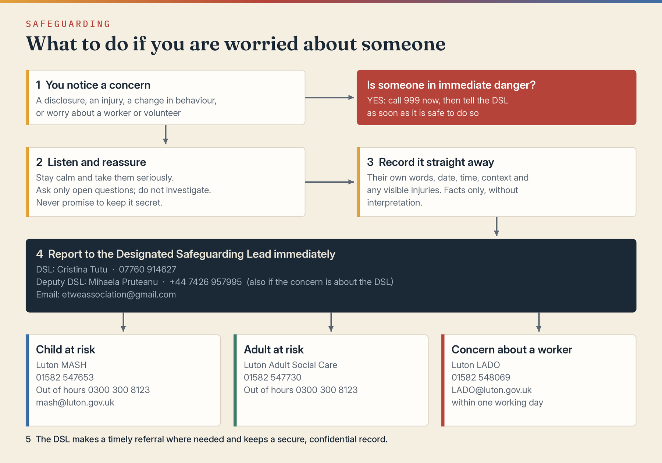

1 Purpose and commitment
East to West European Association Ltd is committed to safeguarding children and adults at risk who come into contact with its services, projects, events, staff, volunteers and partners. Safeguarding is everyone’s responsibility. The welfare and safety of the person at risk will take priority over organisational reputation or convenience.
This policy sets the minimum arrangements for prevention, safer working, recognising concerns, reporting, referral, record keeping and organisational learning. It applies in England and must be read with local safeguarding partnership procedures.

2 Scope and definitions
A child is anyone under 18. An adult at risk is an adult who has needs for care and support, is experiencing or at risk of abuse or neglect, and because of those needs is unable to protect themselves. A person may be vulnerable because of circumstances even where the statutory adult-at-risk definition is not met.
Abuse may include physical, sexual, emotional or psychological abuse, neglect, domestic abuse, financial or material abuse, discriminatory abuse, organisational abuse, modern slavery, exploitation, self-neglect, online abuse, radicalisation, trafficking, hate crime or harmful practices.

3 Legal and practice framework
This policy is informed by the Children Acts 1989 and 2004, Care Act 2014, Safeguarding Vulnerable Groups Act 2006, Domestic Abuse Act 2021, Mental Capacity Act 2005, Data Protection Act 2018 and UK GDPR, Working Together to Safeguard Children 2026, and relevant local procedures. Statutory duties differ by role; the Association will identify the obligations applying to each activity.

4 Governance and named roles
The Board retains overall accountability. The Board has appointed the Designated Safeguarding Lead and deputy named below, will ensure their competence, and makes this reporting route available at every activity.
- Designated Safeguarding Lead: Cristina Giorgiana Tutu · 07760 914627 · etweassociation@gmail.com
- Deputy Safeguarding Lead: Mihaela Veronica Pruteanu · +44 7426 957995 · etweassociation@gmail.com
- Children’s social care, Luton MASH: 01582 547653 · out of hours 0300 300 8123 · mash@luton.gov.uk (for children living elsewhere, use that area’s local authority)
- Adult safeguarding, Luton Adult Social Care: 01582 547730 · out of hours 0300 300 8123. Concerns about a worker or volunteer, Luton LADO: 01582 548069 · LADO@luton.gov.uk
- Immediate danger or crime in progress: call 999; non-emergency police: 101

5 Prevention and safer delivery
Safeguarding must be considered at project design, risk assessment, partnership and venue-selection stages. Activities involving children or adults at risk must have appropriate supervision, consent, staffing, communications, transport, photography, online-safety and missing-person arrangements.
- use role descriptions, proportionate safer recruitment, references and identity checks
- obtain the legally permitted level of DBS check where the role is eligible; from 1 September 2026 regularly supervised volunteers undertaking regulated activity with children may require an Enhanced DBS check with children’s barred list information
- never permit a barred person to undertake regulated activity and make a DBS referral where the legal conditions are met
- avoid unnecessary one-to-one situations and use observable, accountable working arrangements
- obtain informed consent for photographs, recordings, trips and information sharing where required
- ensure partners and contractors have suitable safeguarding standards and reporting routes

6 Recognising and responding to concerns
A concern may arise from a disclosure, observation, allegation, unexplained injury, change in behaviour, online contact, information from another person or concern about a worker or volunteer. Staff and volunteers must not investigate, promise secrecy, confront an alleged perpetrator or delay because proof is incomplete.
- listen calmly and take the person seriously
- reassure them they were right to speak, without promising an outcome
- ask only open questions needed to clarify immediate safety
- record the person’s own words, date, time, context and visible injuries without interpretation
- report immediately to the Designated Safeguarding Lead or deputy
- contact emergency services or the relevant safeguarding authority directly where delay would create danger; tell the safeguarding lead as soon as possible

7 Referral and information sharing
The safeguarding lead will assess immediate safety, consult local procedures and make a timely referral where the threshold may be met. Consent should normally be sought for adult safeguarding referrals, but information may be shared without consent where law permits, including to protect a person from serious harm, protect others, investigate serious crime or meet a legal duty. Children’s welfare may justify sharing without parental consent. Only necessary, relevant, accurate and proportionate information will be shared and the decision recorded.

8 Allegations concerning workers or volunteers
Any allegation that a person working for or with the Association harmed, may have harmed, behaved in a way indicating risk, or may be unsuitable to work with children or adults at risk must be reported immediately to the safeguarding lead and Board Chair. Local authority designated officer procedures will be followed for allegations concerning children. Internal fact-finding must not prejudice police, safeguarding or regulatory enquiries. Protective suspension or role restriction is neutral and not a finding of guilt.

9 Records confidentiality and retention
Safeguarding records must be factual, dated, signed or attributable, stored securely, separated from routine files and accessible only on a need-to-know basis. Records must identify decisions, reasons, referrals, advice and outcomes. Retention will reflect statutory, insurance, contractual and safeguarding needs and the Association’s retention schedule.

10 Training monitoring and review
All workers and volunteers will receive safeguarding information appropriate to their role. The safeguarding lead will maintain a concerns log, review patterns, confirm that actions are completed and report anonymised assurance information to the Board. Serious incidents will be reported to funders, insurers, regulators or other bodies where required.

11 Breaches
A breach may result in removal from an activity, disciplinary or contractual action, referral to safeguarding authorities, police or DBS, and governance review. No person will suffer retaliation for raising a genuine safeguarding concern.

12 References
Working Together to Safeguard Children 2026; Care and Support Statutory Guidance; Charity Commission safeguarding guidance; DBS eligibility and regulated-activity guidance; local safeguarding partnership procedures.

Board approval
This policy was approved by the Board of Directors on 3 August 2026, the date of incorporation, and the approval is recorded in the Board minutes.
Approved by | Board of Directors
Director name | Mihaela Veronica Pruteanu (Director and Chair) and Cristina Giorgiana Tutu (Director)
Signature | Signed copy held at the registered office
Date | 3 August 2026

